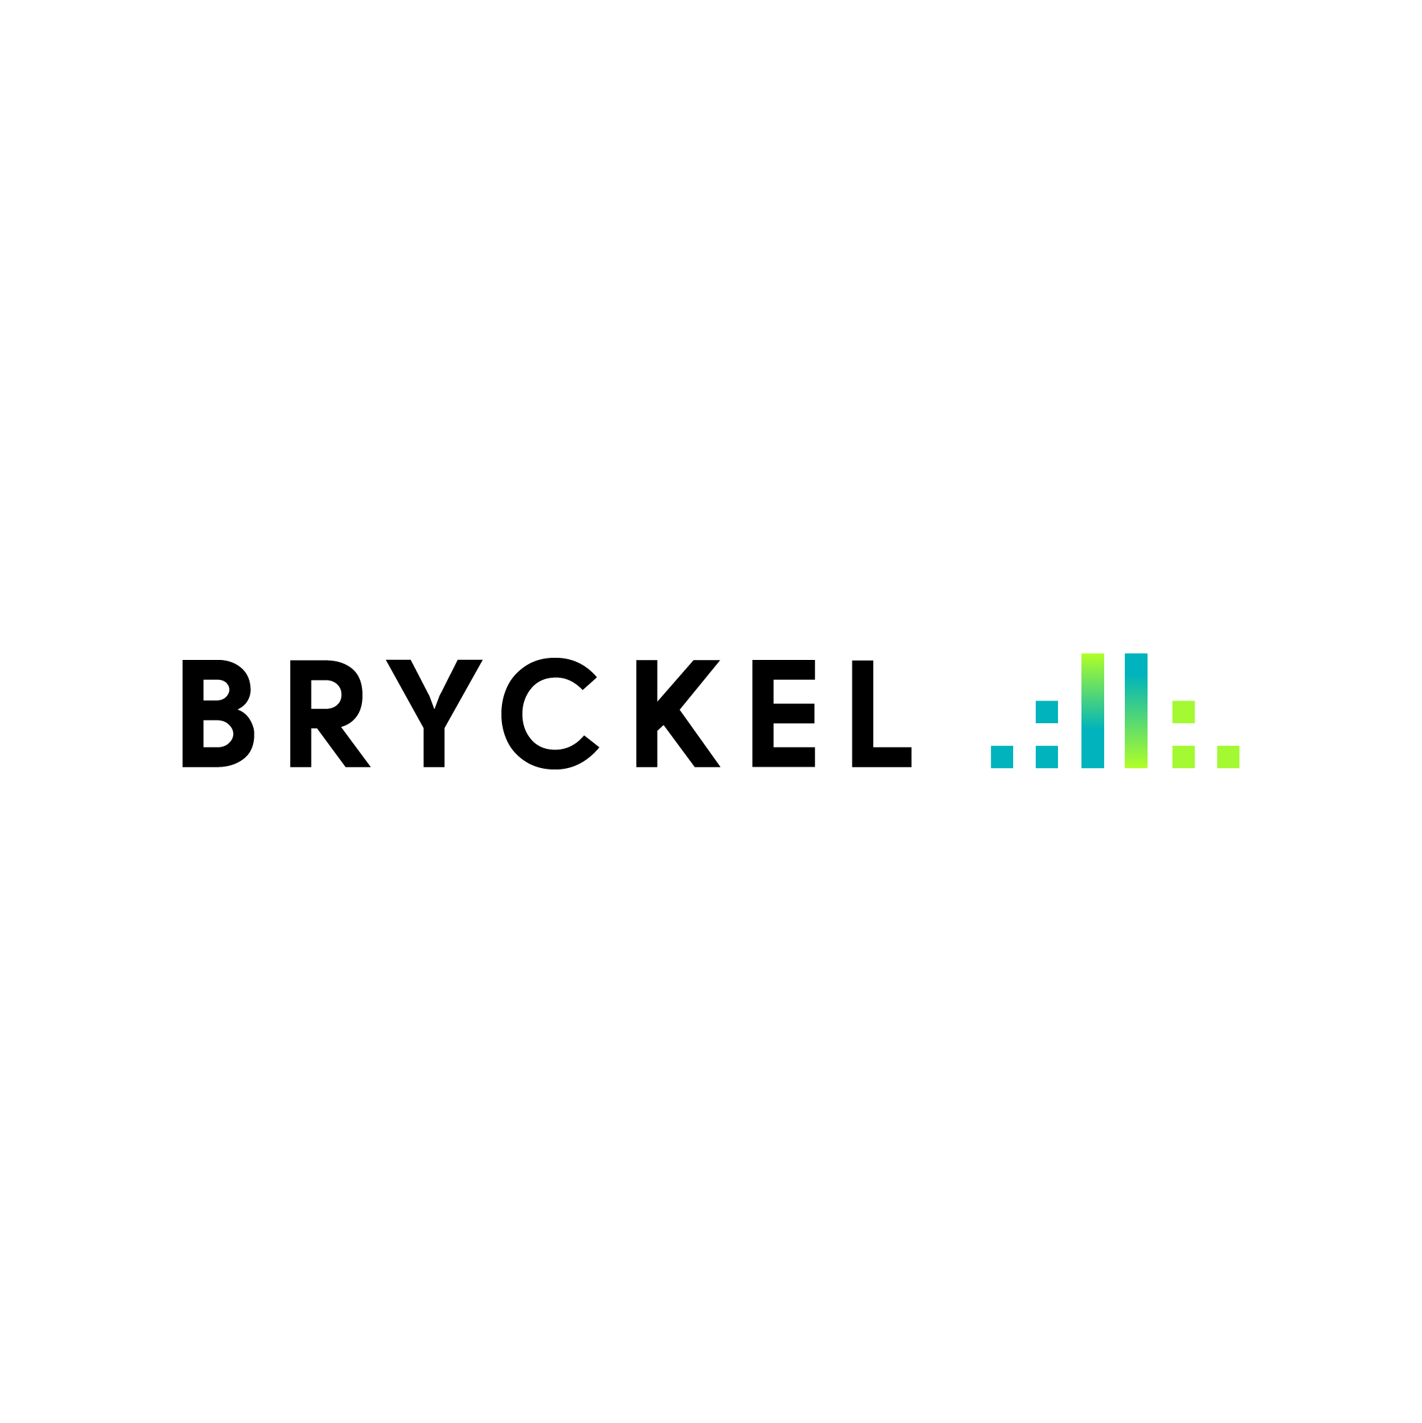

Note: Please do not generate the entire code with AI. We will not respond to “copy & paste” code writing candidates.
While we are not opposed to using AI we want to understand your thinking.
In your brief, share what was coded by you and what was enabled by AI.

Assignment

Assignment: Build an AI-Powered Chat with Source Citation

Objective
Develop a document-aware AI chat system that:
- Ingests a single legal document (e.g., Nelly’s Italian Cafe Lease).
- Produces structured output in the provided lease summary template.
- Enables contextual Q&A while tracing all responses back to their source.
Goal: Evaluate the candidate’s ability to design an end-to-end pipeline — document ingestion, extraction, retrieval, and chat — while reasoning about edge cases.

Scope & Deliverables

1. Document Ingestion & Extraction
- Load and preprocess the attached legal document.
- Generate structured output according to the provided lease summary template.
  - Candidate should extract as many fields as possible. Minimum required fields:
    - Tenant
    - Landlord
    - Lease Start Date
    - Lease End Date
    - Rent Amount
    - Renewal Options
    - Termination Clauses
    - Security Deposit
    - Special Provisions
- Candidate is free to choose the method (e.g., text parsing, embeddings + retrieval, LLM-based extraction, etc.).

2. Chat System with Source Attribution
- Build a Streamlit interface that allows users to ask questions about the document.
- Each answer must:
  - Provide relevant context from the document
  - Include clear source citations (e.g., "Extracted from Page 3, Section 4")
- Multi-turn chat is optional but encouraged.

3. Edge Case Analysis
- Identify at least 5 potential issues the system may encounter. Examples:
  - Ambiguous or missing fields in the lease
  - Conflicting clauses
  - Complex or nested clauses
  - Queries with multiple possible answers
  - Extremely long sections
- Propose strategies to handle these edge cases.

4. Deliverables
- Streamlit App showing:
  - File upload (single document)
  - Structured lease summary output
  - Interactive chat with source citations
- Code repository:
  - Modular, readable code with instructions to run the app
- Report / README:
  - Edge case analysis
  - Pipeline overview and assumptions
  - Discussion of limitations and trade-offs

Evaluation Criteria
- Pipeline Design: clarity, modularity, and reasoning behind approach
- Structured Output: accuracy and completeness of extracted fields
- Chat System: relevance of answers and correctness of source attribution
- Edge Case Awareness: ability to foresee and mitigate potential issues

✅ Note: The candidate has freedom to choose their approach to extraction and retrieval. The purpose is to evaluate design thinking, end-to-end reasoning, and implementation skill, not familiarity with a specific library.

